**NATIONAL INSTITUTE OF TECHNOLOGY KARNATAKA**

**SURATHKAL**

**DEPARTMENT OF INFORMATION TECHNOLOGY**

**POP PROJECT**



**“Simple Quiz System “**

**Submitted to**

**IT 206 (POP)**

**DEPARTMENT OF INFORMATION TECHNOLOGY**

**Nov. 27, 2018**

**By**

Venkatesh B H Niteesh Kumar

17IT248 17IT228

[venkubh@gmail.com](mailto:venkubh@gmail.com) niteesh0112.nk@gmail.com

Rashad Ahmed Vishal Nirne

17IT132 17IT250

[rashadahmed163@gmail.com](mailto:rashadahmed163@gmail.com) [vishalnirne98@gmail.com](mailto:vishalnirne98@gmail.com)

**ACKNOWLEDGEMENT**

ENTRANCE…Hard work…gradual progress and second year. That’s how we have reached this level and now we stand at the two years which we have spent in this college.

Training is agglomeration of the theoretical and practical and technical concepts, which enhances our skills in the field of technology.

We sincerely acknowledge our thanks to the teachers for their guidance and motivation throughout the training and project work.

We would also like to record our gratitude to Dr. Biju for giving us a chance for learning here.

Last, but not the least, we would like to thank all our companions for their help which was in abundance

**ABSTRACT**

QUIZ SYSTEM is a software in which we have specified some questions, a timer runs for given time and within that period one has to answer for all those questions, some buttons are presented at the bottom of the window like start button, previous, next, finish.

When we click the start button the online test get started, you will have to answer 25 questions within 10 minutes, the timer runs.

If you do not wish to answer a particular question you can move on to next question by pressing next button or if you wish to move to the previous question that you had skipped you can make this move by previous button.

The environment used for this project is JAVA. This project is based on core JAVA. The software used for this is java in Windows operating system.

**TABLE OF CONTENTS**

CONTENTS

1. Introduction ………………………………………………….
   1. Objective
   2. Areas of application
2. System Analysis……………………………………………...
   1. Feasibility Study
      1. Technical Feasibility
      2. Economic Feasibility

3. System Design………………………………………………..

* 1. Modules and their description
     1. Administrator Module
        1. Enter Questions and Answers
     2. User Module
  2. E-R diagram
  3. Use-Case diagram
  4. Activity diagram
  5. Collaboration diagram

1. Conclusion & Future Scope…………………………………
   1. Conclusion
   2. Future Scope & Application Area
   3. Advantages
   4. Limitations

References & Bibliography

**1.INTRODUCTION**

The Quiz System is a software in which we have specified some questions, a timer runs for given time and within that period one has to answer for all those questions, some buttons are presented at the bottom of the window like start button, previous, next, finish.

When we click the start button the quiz gets started, you will have to answer 25 questions within 10 minutes, the timer runs.

If you do not wish to answer a particular question you can move on to next question by pressing next button or if you wish to move to the previous question that you had skipped you can make this move by previous button.

**1.1** **OBJECTIVE**

This concept of online test fulfils the following requirements:

* It provides a less expensive as well as an effective method of performing examinations.
* It provides best facilities for the students to answer the question only with a single click.
* It saves time as well as money.
* It lessens the student’s and teacher’s frustration.

**1.2 AREAS OF APPLICATION**

* **Across the globe**: This project finds it application in conducting examination over the globe.
* **Student’s needs**: It saves time as well as money. It lessens student’s frustration.

**SYSTEM ANALYSIS**

**2.1 FEASIBILITY STUDY**

Feasibility study defines all the requirements to performance characteristics of system.

For system to be feasible, the design needs to undertake various factors or performance requirements by which the system will be operated.

A feasibility study is short, focused study which aims at selecting the best system that meets performance requirements. Information is gathered regarding the general requirements of the proposed system.

If feasibility study is to serve as the decision document, it answers a number of questions. Like

* Is it beneficial?
* Does it save time and money?
* Can it be integrated with other systems already in place?

Planning resources is a very vast concept and we are beginners, thus including each and every aspects of web, Integrate and automate them in every respect was not feasible for us. The concept of Online Testis newer. The project is built with the help of **JAVA** technology which is reliable and efficient platform to work upon. This concept saves time.

**2 .1.1 Technical feasibility**

Technical feasibility takes of the all the issues concerned with the design and the development part of the project. It concerns itself with the software, hardware and the platform related issues. The following are the technical specifications for our project.

The project would require a lot of space for storage of static as well as dynamic content.

As the number of project available increases the space required for storing them increases.

**2.1.2 Economic feasibility**

* It provides an efficient and reliable platform to work upon.
* It saves time and is thus a faster means of examination.
* It is less costly than the other means of examination.

**SYSTEM DESIGN**

**3.1 MODULES AND THEIR DESCRIPTOIN**

**3.1.1 Administrator module**

The administration process can be complex and must be properly planned and managed to ensure a successful project. Administrators are a professional team trained to follow a project plan that has been designed specifically for you. Administrator develops software and enhances it process. Administrator in online test project based on Core Java enters questions and answers in an array. He created software for online test in which he created a window which is partitioned into four parts: North, South, East, and West. North Window: He has provided a Welcome note for the user with user name and timer runs after clicking start button. South Window: He has created buttons to start the test, to move to the next question, to finish the test and two buttons to navigate back to previous or next question after finishing the test to check the answers. East window: Questions are displayed in this window. West window: Options are given in this window with check boxes, check boxes are checked for the correct answer.

**3.1.1.1 Entering Questions and Answers**

While creating software for online test,He has entered questions only in an array and placed them to the East window. And options to choose correct answer are in West window.

**1. Enter questions for test**

**2. Enter answer options for Users**

**3.Check questions and Display**

**3.1.2 User module**

User only has to enter the name and proceed to answer the questions. User click the start button and timer starts, user have only ten minutes to answer all the questions. After answering all the questions, user click finish after the test and answer will be displayed for all the questions. Users click check previous or check next for checking correct answer.

1. **Enter name.**
2. **Answer the questions.**
3. **Finish the test and Check correct for correct answer.**

**3.2 E-R DIAGRAM**

An entity – relationship model describes interrelated things of interest in a specific domain of knowledge. A basic ER model is composed of entity types and specifies relationship that can exist between instances of those entity types.

GIVES

ONLINE TEST

CANDIDATE

**3.3 USE – CASE DIAGRAM**

A use case diagram at its simplest is a representation of a user’s interaction with thw system that shows the relationship between the user and the different use cases in which the user is involved.

Quiz master

Participant

Questions

Report

Participation

Registration

Scoring

**3.4 ACTIVITY DIAGRAM**

Activity diagram is another important diagram in UML to describe the dynamic aspects of the system. Activity diagram is basically a flowchart to represent the flow from one to other activity.

Pass

Increment Score

Stop

Next Question

Check

Conduct Quiz

Start

Name

Result

Status

Rules

Ask Questions

Quiz Master

Questions

Report

Participant

SEQUENCE DIAGRAM: -

Sequence diagrams are sometimes called event diagrams or event scenarios. A sequence diagram shows, as parallel vertical lines, different processes or objects that live simultaneously, and, as horizontal arrows, the messages exchanged between them, in the order in which they occur.

Awaiting

Participation Details

Generate Report

Analyse Answer

Display Result

Answer

Ask Question

Get Question

Select Question

Give Details

**3.5 COLLABORATION DIAGRAM**

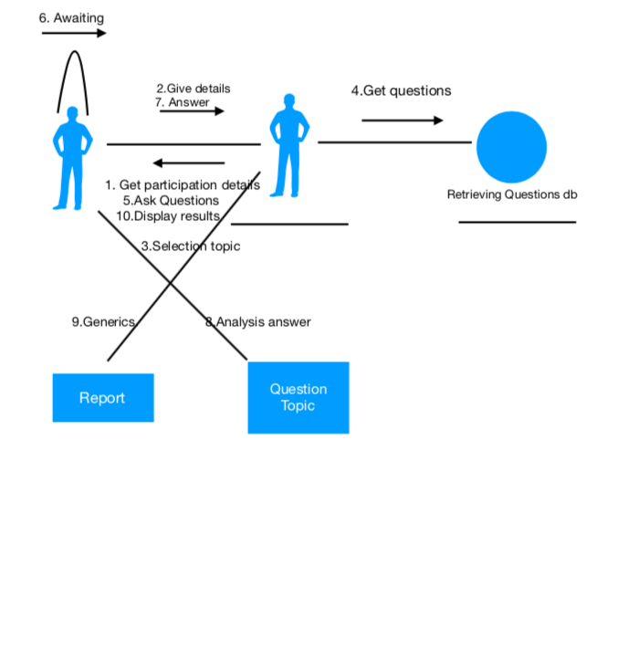

A collaboration diagram, also called a communication diagram or interaction diagram, is an illustration of the relationships and interactions among software objects in the Unified Modeling Language(UML). The realtionships between the objects are shown as lines connecting the rectangles.

**4.CONCLUSION AND FUTURE SCOPE**

**4.1 CONCLUSION**

Computerization is needed in this Shrinking world, where centralization is also required with globalization. Conducting online test is a step in this direction to ease the current structure of examination. This way of conducting test on one of the most secure operating system and with highly sophisticated technology is cost effective and save time too.

This way of conducting test not only save time but also lessens student’s and teacher’s frustration. It is an easier way of giving examination, any person across the globe can appear for the examination.

* 1. **FUTURE SCOPE**

It has vast future scope, as it is not made for client server level so we can make it for client server level too.

Every type of exam can be conducted online and it will lessen the teacher’s frustration.

We can also conduct tests for various subjects and various difficulty levels.

**4.3** **Advantages of the software**

* Since this software is designed in java, it is Platform independent.
* Successfully handles the problem.
* Reliability gives consistent results.
* System is robust.

**4.4 Limitations of the software**

* All the questions have to be scrolled once before clicking the finish button
* A user must have fundamental knowledge as to how to use the application

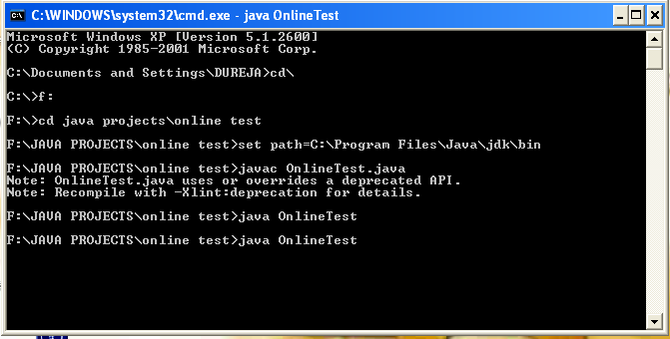

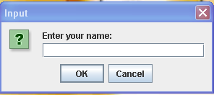

**Fig-1**: The above interface is when the participant is prompted to enter his/her name.

If the participant enters the quiz with an empty text field as the name, then “Anonymous” is taken as the name by default.

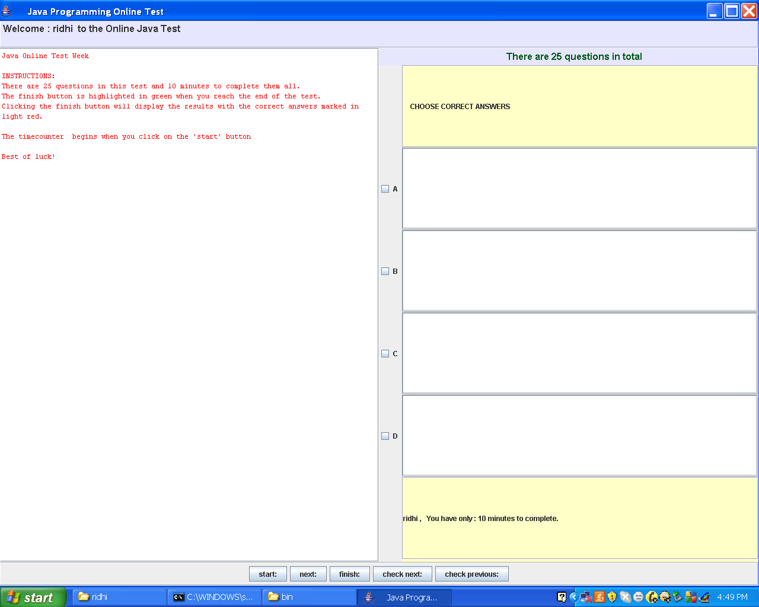

**Fig-2:** The interface is prompted after the participant has submit his/her name.

The instructions are clearly displayed on the centre block of the interface. The different buttons to proceed through the steps are mentioned on the bottom of the block.

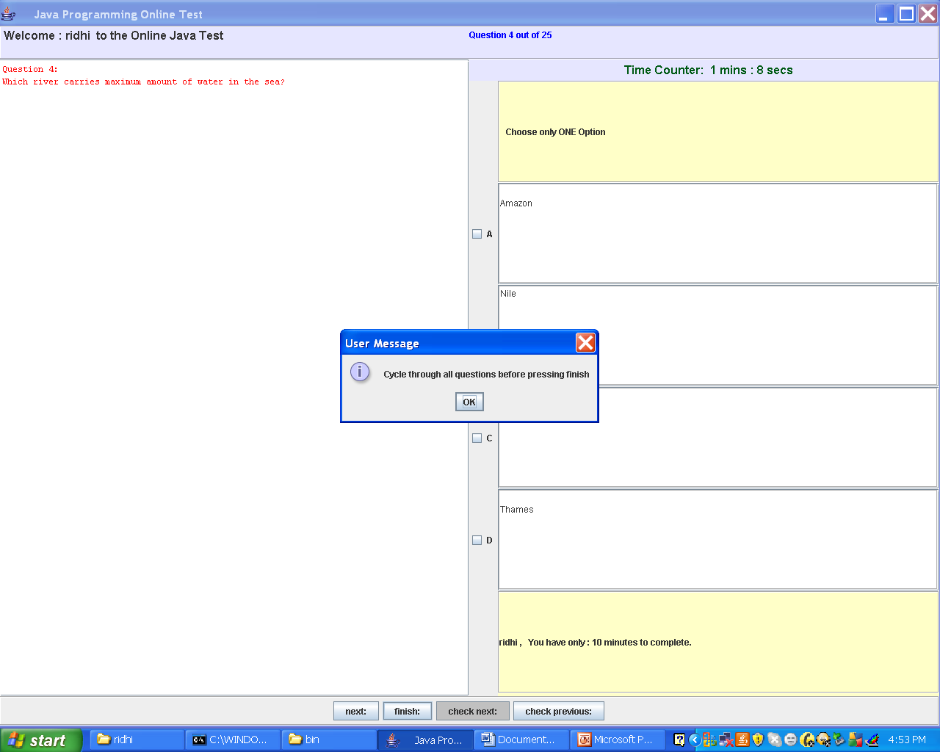

**Fig-3**: The above-mentioned message pops up when the participant tries to submit the quiz without scrolling through all the specified questions.

Hence to submit the quiz one has to scroll through all the questions with or without attempting them.

**BIBLOGRAPHY**

**BOOKS:**

The Complete Reference Java 10th Edition

By: -Herbert Schildt

Programming with Java

By: -E Balagurusamy

**WEBSITES:**

[www.](http://www.)java.sun.com

[www.google.co.in](http://www.google.co.in)

en.wikipedia.org

**CONCLUSION**

The project entitled “SIMPLE QUIZ SYSTEM” has been successfully complied and made to run using the following main components of core Java:

* EVENT HANDLING
* EXCEPTION HANDLING
* LAYOUTS
* SWINGS